**Zensar SAP API consume module for Magento 1.9**

1. Install the Zensar_Sap module.
2. For testing purpose we were calling the Magento SOAP API itself once you confirmed that our module is working fine then we can change the admin setting and code as required to give SAP call to SAP system.
3. For this we have to create SOAP User with all SOAP role from admin panel.

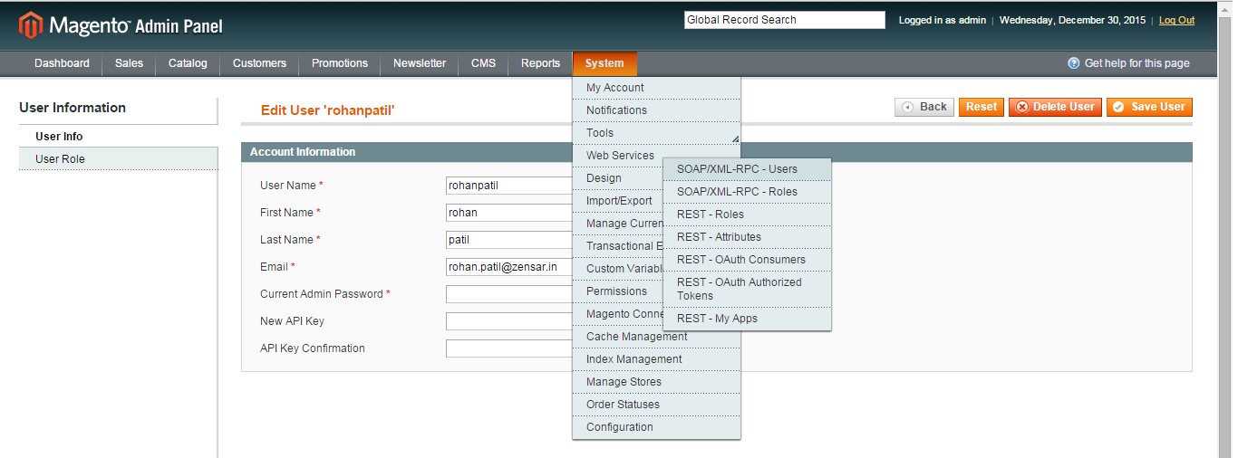

1. Once all role and account has been created then configure the same in SAP Admin configuration.

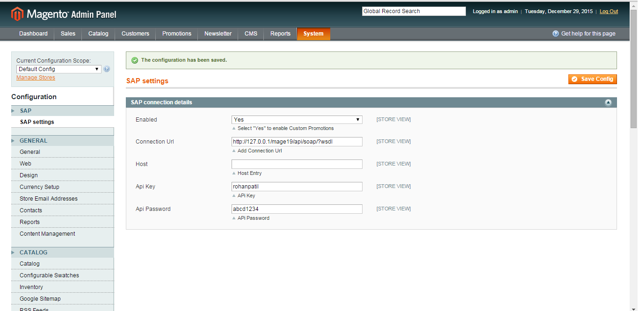

1. Now for testing we were trying to give a call to default SOAP function to get product list using module URL.  
     
   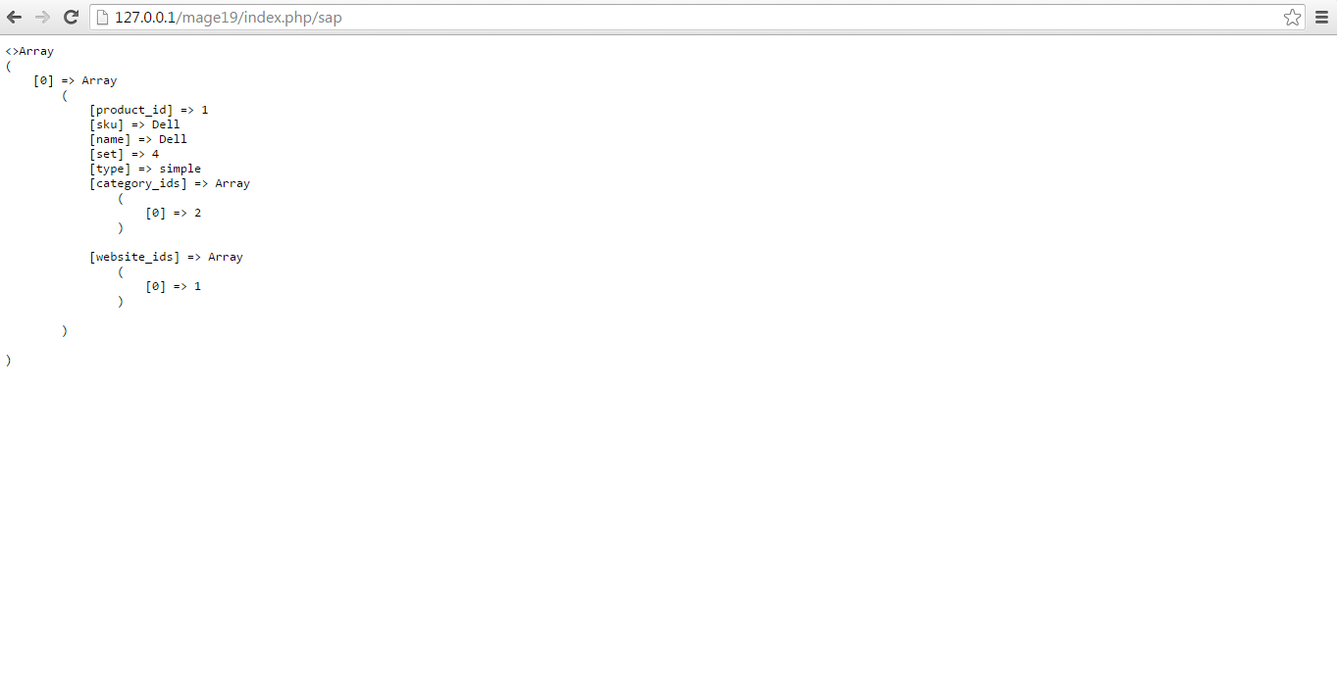
2. Once this is working fine then we have change the configuration setting and code listed in modules Model file.